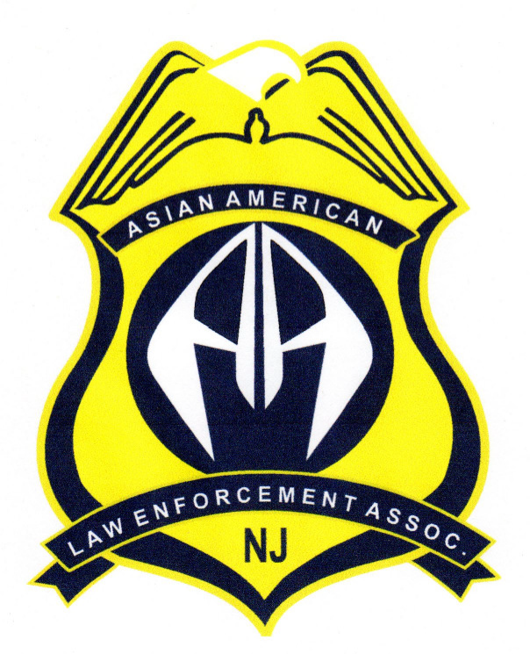
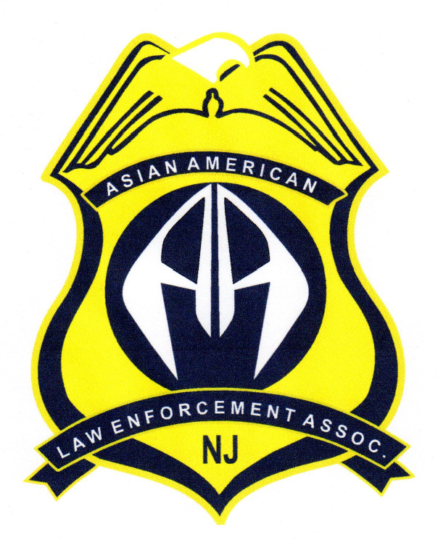
New Jersey
Asian American Law Enforcement Officers Association

P.O. Box 958 Old Bridge, New Jersey 08857 WWW.ASIANCOPS.ORG

Sworn Membership Application-2020

Enclosed is my New Jersey Asian American Law Enforcement Officers annual dues of $40.00 NJAALEOA shirts are $15.00 each. Membership may be paid via Pay Pal at www.njaaleoa.org

NAME: ADDRESS:
CITY: STATE: ZIP CODE: HOME PHONE: CELL PHONE: EMAIL:
AGENCY:
AGENCY ADDRESS:
CITY: STATE: ZIP CODE: WORK PHONE: FAX:

WORK EMAIL:
SPECIAL INTERESTS AND SKILLS:
Years of Service:

S M L XL 2XL
ENCLOSE COMPLETED APPLICATION AND CHECK PAYABLE TO NJ ASIAN AMERICAN LAW ENFORCEMENT OFFICERS ASSOCIATION AND MAIL TO P.O.BOX 958 OLD BRIDGE, NJ 08857
PLEASE INDICATE YOUR SHIRT SIZE

ASSOCIATION USE:

Date Application Received: Date Shirt & Association Cards Sent:

