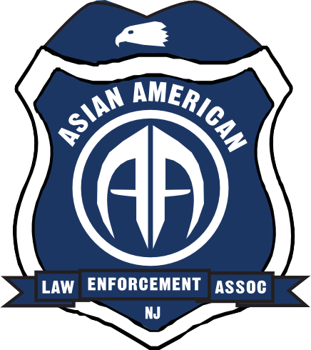
19th Annual Asian Fest
SATURDAY
June 30-12 noon to 4pm

kids
the piñata, water balloon toss, the limbo many other games, fingerprinting, Police vehicles and much more. Giveaways for all the kids

Adults
ZumbA DANCE CONTEST with Millie
Chef Lawson working the grill, with burgers, hot dogs and BBQ Chicken Chinese food, Korean food, Filipino food, Asian Indian food

MUSIC

Career fair
The New Jersey State Police, The Bureau of Alcohol, Tobacco, Firearms & Explosives, The Pennsylvania State Police, The Federal Bureau of Investigation, The US Air Marshal Service, The Internal Revenue Service, The Middlesex County Prosecutors Office, The Bergen County Sheriff's Office, US Customs Border Patrol, Edison PD, Fanwood PD, the NJ State Department of Corrections, US Postal Service , New York City PD, Philadelphia PD, Port Authority of NY & NJ PD, US Capitol Police
The New Jersey Asian American Law Enforcement Officers Association with the Society of Asian Federal Officers presents.....
PRICE: Members free, 8 years & over $10.00 per person
(no charge for college students only attending the career fair)
WHERE: Yelencsics Park 2963 Woodbridge Avenue Edison NJ
Special thanks to: The Shu-wai Lam Family Foundation, SAFE BENEFITS, Bancroft Neuro Rehab, Asian Food Markets, Newport 7-11, Carvel- Somerset, Valero gas station Jersey, City Imperia Banquet Center, DCH Auto Group,
2018 NJ Asian American Law Enforcement Foundation Scholarship to be awarded at the event.

Joe 732 763-4414 • Ray 201 281-2000 • Neel 732 983-8058 or Jamie 908 812-0532

